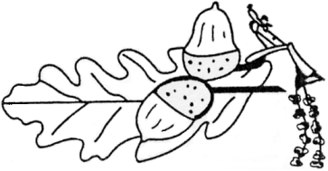
COPLE LOWER SCHOOL

21st April 2016
Dear Parents/Carers,

We are writing to introduce the new governing body for the Cople Willington Federation. As you are probably aware, the schools federated on 1st April at which point the two previous governing bodies stepped down. Yesterday evening the new governing body met, where appointments were confirmed.
Your federation governors are:
Cople Headteacher (ex officio) Helen Johnson
Willington Headteacher (ex officio) Elizabeth Dun
Elected Parent (Cople) Cindy Tucker
Elected Parent (Willington) Vicky Maples
Elected Staff Elaine Sawford-Smith
Local Authority Appointed Rob Baxter (Chair)
Co-opted Philla Ebbs
Co-opted Keith Ferguson
Co-opted Lyn Heywood
Co-opted Rhys James
Co-opted James Marco (Vice-Chair)
Co-opted Owain McNeill
Co-opted Anthony Pallant
Co-opted Julia Staley
Co-opted Mary Whitehead
Associate Member Siobhan Godden

The governing body will now be starting their work supporting the management of both schools and planning the next steps in the schools’ future. I hope you will get the chance to meet some of the governors throughout this term.You can contact any governor via either school office.

Yours sincerely

Helen Johnson Elizabeth Dun
Headteacher Headteacher
Cople Lower School Willington Lower School

