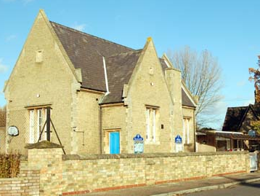
WILLINGTON LOWER SCHOOL
‘A great school in the heart of our village’
Newsletter

OCTOBER 2015
Issue 30

A Values School

OUR VALUE THIS MONTH:

PERSEVERANCE


Stars of the Week in September were:

Reception: Emmi, Aisha and Bethany
Year 1: Camille, James and Olivia O
Year 2: Dylan, Bailey and Rebecca,
Year 3: Skye, Fionan and William,
Year 4: Tommy, Thea and Harriet

The Values Award from The Golden Box draw was won by Camille, Thea and Kyle for showing kindness to their fellow students and teachers
Achievements Outside School:
William and Olivia Parker for completing the Summer Reading Challenge.

Finlay for gaining a distinction in poetry recital (LAMDA)

Joel for scoring lots of goals, winning a medal and being man of the match whilst playing local teams and in Tottenham Hotspur Soccer School.
Joel has also received a medal for attending tennis club during the summer holidays.

Well done everyone!

Reminders

Please can we remind Parents/Carers of a few dos and don’ts around school in the interests of health, safety and your child’s wellbeing:
• Do please remember that bicycles and scooters must not be ridden in the school grounds. Please walk with your child’s scooter and/or bicycle until you are outside the school gate.
• To meet stringent child protection legislation, please be aware that mobile phones cannot be used in the school grounds. This is to ensure the safeguarding of all our children.
• Children should always attend school in full school uniform.
• It is vitally important to update any changes to your child’s contact details, especially mobile phone numbers of ALL your child’s emergency contact people. Poorly children get very dis-tressed when we cannot get hold of anyone to collect them.

Thank you for your continued support.
CHAIR OF GOVERNOR’S ACHIEVEMENT AWARD

I’m delighted to announce that Rob Baxter, our Chair of Governors, has achieved an award in recognition of his services to the school. This was presented by the Mayor of Bedford at an Awards’ Ceremony at Borough Hall last month. Rob is a dedicated supporter of Willington Lower School and we congratulate him on his achievement!

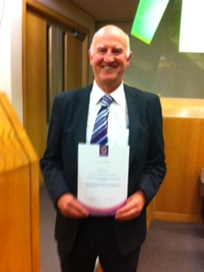

Hi. I’m Rob Baxter and I have been Chair of Governors at the school for just over two years now. In order to fulfil my role to the maximum I decided, in April 2014, to undertake and study for the accredited Chair of Governors’ Leadership Development Programme, organised through the National College for Teaching and Leadership. This course enabled me to assess and develop my leadership skills through attending evening classes, having a mentor and keep a learning log, which, for me, was a reflection on how I have helped the governing body to develop over the past two years. It’s important to ensure that strong governance (supporting and setting the aims and objectives of the school, supporting and challenging the headteacher and school staff through policies and procedures and ensuring that we have a balanced budget and that money is well spent) continues at our school.
I completed the Programme in March this year and I would like to thank governors and particularly Mrs Dun for their support for my work in the Programme.

Rob Baxter
LABELLING CLOTHING AND EQUIPMENT AND
LOST PROPERTY

We always gather a large number of lost property items throughout each term, many of which are unnamed, and so are never reunited with their owners.
We recognise the significant cost of both equipment and clothing to parents and we would be much better placed to return items if they are clearly named. Thank you.

CHARITY DAY 9th OCTOBER

A few of our Year 4 children are organising a cake and toy sale in aid of Macmillan. Everyone can buy a cake during break in the morning and there will be the opportunity to buy toys and more cakes after school. This is the children’s own idea and I hope that you can support their efforts for this worthy cause.
9th October is also the Red, White and Blue Day in support of our service men and women in the British Army, Navy and Air Force. The children are welcome to enter the patriotic spirit and come dressed in these colours. All donations will be appreciated.

NEWS FROM OAKS

Music stars in the making

Oak class has had a very musical start to the year as they have begun to learn to play the ukulele.
Mrs Choy Winters visits the class every Tuesday afternoon to teach the instrument. The children are taking their ukuleles home between lessons to hone their skills. Everyone is looking forward to participating in the concert next term. (More information about this will follow closer to the time.)

Red, White and Blue Day

On Friday 9th October we are asking children to come to school dressed in red, white and blue with a donation of £1. Red, White and Blue day is a national event intended to raise money for charities supporting members, ex-members of the army, navy and airforce and their families.

School Council

A new school year means school council elections. Our school council members this year chosen to represent their classes are: James Jones, Harvey Honeybourne, Fionan McTernan, Tommy Newstead, Zachary Pallant and Eleanor Hickton. We are sure that they will all do an excellent job of supporting their classmates.

Mrs Louise Buisson

NEWS FROM ACORNS

We had an exciting start to the term when, on the first day back to school, a kite seemed to have got stuck in the playground tree. We made kites and when we went down to the village hall field to fly them, we were very surprised to see a large hot air balloon basket and deflated balloon. We had great fun climbing in the basket, watching the burners and learning about the hot air balloon from Kerry and Ollie the pilots. They had kindly agreed to visit us and help with the ‘Stunning Start’ to our new topic ‘Up up and away’......

Since that first day, we have looked at the history of balloon flight. We found it amusing that the passengers of the first balloon flight in 1783 were a duck, a sheep and a rooster! We have experimented with heat and candles trying to make our own small working hot air balloon but found this very difficult. Although we didn’t get our bags to float up it made us think scientifically about changing our designs.
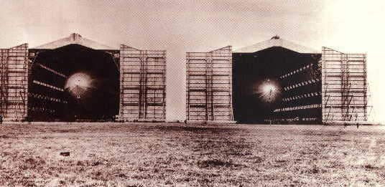
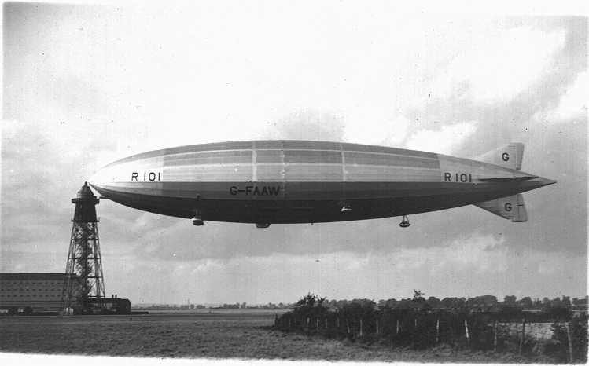
This week we have been looking at the local Cardington Hangers and researching airships. The R101, which was made in the Cardington hangers, started its final flight from Cardington in 1930 before it crashed in France. We watched black and white movie clips of the hangers, the R101 and the Hindenburg, a German airship. This has generated a lot of discussion and interest.
We are fortunate that this is a significant historical worldwide event and a huge part of our local history. We are now looking forward to history being made again as a new airship is being built in one of the hangers and we believe it is due to start test flights over Cardington and the surrounding villages at the end of October and November. Very exciting!
Mrs Heidi Smith

NEWS FROM SQUIRRELS

September brings a new school year and a new consignment of squirrels!
We are pleased to welcome 13 new squirrels to our school. They are all settling in well and beginning to find their way around the school. Obviously we have spent a lot of time outside as the weather has been so nice. We have been busy digging in the garden, working in our mud kitchen and exploring the water and sand.

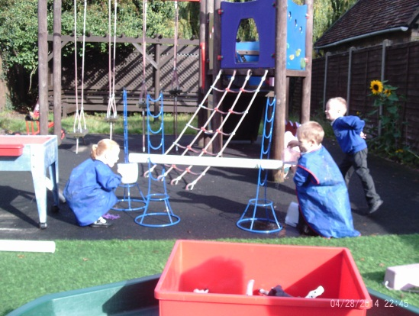

We also shared our baby photos and thought about all the changes that have happened in our lives so far – Mrs Staley even brought in her own photo which was easy to spot as it was the only one in black and white!
We are looking forward to an exciting year ahead as we follow squirrels through their first year of school.

Mrs Julia Staley

NEWS FROM THE FRIENDS
The Friends had a very successful year, raising lots of money but most importantly we organised events that the children enjoyed, hopefully creating lots of happy memories from their time at Willington.
We organised Christmas and Summer fairs, a Valentines disco, Easter Egg Hunt, a Mothers Day shop, Christmas cards designed by the children, an end of year picnic as well as Mufti days and cakes sales throughout the year. We also provided refreshments at the monthly Village Market.
We have donated a considerable amount of money to the school paying for the snacks that children in Oaks receive every day; bought memory cards, dictionaries and subsidised trips to the Pantomime and Woburn Safari Park.
It is hoped we will have another successful year and have lots more events planned including a Mufti day and Halloween Disco on 23rd October, an opportunity to buy Christmas cards designed by your child and a Christmas Fair later on this term.
The Friends held their AGM this week, when we said goodbye to some members and welcomed new ones. Thank you to everyone for their hardwork and if you are interested in joining us in any capacity, be it helping us plan and run events or just providing a cake for the village market, please let us know.

HARVEST FESTIVAL

Our Harvest Festival service will take place on Tuesday 13th October at 9.30am at the Methodist Chapel (please note change of venue).
The Friends of Willington Lower School (FoWLS) have kindly offered to provide tea and coffee.
Any donations of dry or tinned food goods will be gratefully received on the day and we will be passing these to the St. John’s Hospice in Moggerhanger.

UPDATE ON THE REPLACEMENT BUILDING

We are back on track with this project with the current Care Club building to be removed during half term.
Care Club will operate in Oak class during November & December. We have been informed that the new building will be in place and functional by the end of term ready for use in January 2016.
We will keep you informed as plans progress.

CONTACT DETAILS

Our email address has changed to office@willingtonlowerschool.org

Our phone number remains as 01234 838280.

UNIFORM
Please ensure children come to school wearing the appropriate uniform. Fashion jewellery and nail varnish is not permitted. Earrings should be studs only. This is a good habit to get into and standard practice in most schools.

PARENTS QUESTIONNAIRE

Please complete and return the questionnaire which your child is bringing home tonight. We are always looking for ways to improve the school and value your suggestions and feedback.

DIARY DATES:
OCT  9th  12th  13th  19th  21st  23rd  NOV  2nd  3rd  3rd- 5th  9th  18th  23rd  27th  DEC  15th  18th | Red, White & Blue Day + After school Cake and Toy Sale in aid of MacMillan organised by a group of Year 4 children  Curriculum Governors Meeting  Harvest Festival 9.30 at the Methodist Chapel (note change of venue)  Parents/ Carers invited into classrooms from 3pm  Cluster Football Tournament for selected squad from Oak Class  Wear Something Pink Day in aid of breast cancer and coffee morning 9am-10am, organised by FoWLS  Halloween Disco  Last day of half term  Teacher Training Day  Children return to school  Parents’ Consultation Meetings times tbc  Finance Governors Meeting  Bedford Faith Tour for Years 1,2,3,&4  Full Governing Body Meeting  Coffee Morning with Mrs Dun – an opportunity for parents/ carers to have a drink and a chat 9am-10am  Pantomime at Wellingborough Theatre  Last day of term

