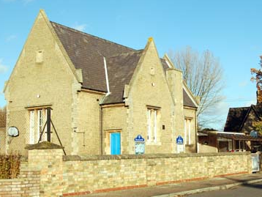
WILLINGTON LOWER SCHOOL
‘A great school in the heart of our village’
Newsletter

NOVEMBER 2015
Issue 31

A Values School

OUR VALUE THIS MONTH:

FAIRNESS



Stars of the Week in October were:

Reception: Callum,Rae,Talia, Lilly-Mai
Year 1: Tasmin,Elliot, Olivia P, Gabe
Year 2: Harvey, Ellie, Kyle, George
Year 3: Archie, Marika, Lucas, Evan
Year 4: Lewis, Zachary, Aoife, Ollie

The Values Award from The Golden Box draw was won by Mrs Smith for persevering with a very frustrating maths puzzle – and she succeeded!; to Myles for finding someone’s coat on the floor and kindly hanging it up; and to Tommy for lending Freddie his pick during the ukelele lesson.

The Playground Awards for October go to Thea, Marika, Sophia, Matteo, Aoife, Nate, Mila and Freddie.
Achievements Outside School:
Myles achieved an award for swimming five metres.
Eden has achieved her level eight at gymnastics.
Harrison has been congratulated by PRO Landscapes for being rugby Player of the Week in Ampthill.
Well done everyone!

LABELLING CLOTHING AND EQUIPMENT AND
LOST PROPERTY

We always gather a large number of lost property items throughout each term, many of which are unnamed, and so are never reunited with their owners.
We recognise the significant cost of both equipment and clothing to parents and we would be much better placed to return items if they are clearly named. Thank you.

CHARITY DAY 9th OCTOBER

Mila, Aoife, Harriet, Thea, Eleanor, Tommy and Harrison in Year 4 organised a cake and toy sale in aid of Macmillan. This was the children’s own idea and their efforts raised £92.95.
9th October was also the Red, White and Blue Day in support of our service men and women in the British Army, Navy and Air Force, and a total of £48.11 was raised for this. Thank you for your support!

NEWS FROM OAKS

General News
As the term has progressed we moved from hot air balloons to airships. The children researched, wrote and recorded some excellent news reports about the fateful maiden voyage of the R101 from Cardington Hangars. In the last couple of weeks we have been learning about the Wright Brothers and their famous early aeroplane. The information pages produced about this have been very interesting. In art we have thought about the view from air transport and produced fantastic, textured 3D art work of parts of our landscape seen from a bird’s eye view.

Gym
Over the last six weeks we have had the benefit of a gymnastic expert working with the children
to develop movement sequences. The children used the school’s iPads to record sequences then review them to guide improvements before a final performance.

Duxford
On Thursday 22nd October we went to the Imperial War Museum at Duxford. The children really enjoyed putting their learning into context with a walk through Concorde being a big highlight. The teaching session, led by a member of Duxford staff, taught them a lot about how planes fly and allowed learning about forces to be put into context.

Egg-Citing project!
All children will need a six egg, egg box for their DT project this term. If these could be bought in within the first three weeks then that would be fantastic. (If you have more then one please send in extras – thank you!)

Mrs Louise Buisson

NEWS FROM ACORNS

During the month of October we continued our topic, ‘Up up and Away’. In History and English, we looked at the Wright Brothers and their invention of the flying machine and used a time line to plot the history of flying machines throughout the ages. For Design Tecnnology we designed and made different styles of paper aeroplanes which we had great fun in testing and flying, we then changed our designs to make the plane fly better. We also designed and made our own Wright brothers, wooden bi-planes out of pegs and lolly sticks.
To look at the many different machines that fly, we visited Duxford Air Museum. This was very exciting and a fantastic learning experience for all the children. We learned about how planes fly and also made our own rockets and gliders during a session lead by an education officer from Duxford. As we walked around the exhibition we saw old and new planes, including Concorde which we were able to walk through. We were able to see for ourselves the size of the planes and we also, while outside, were lucky enough to see a bi-plane take off.
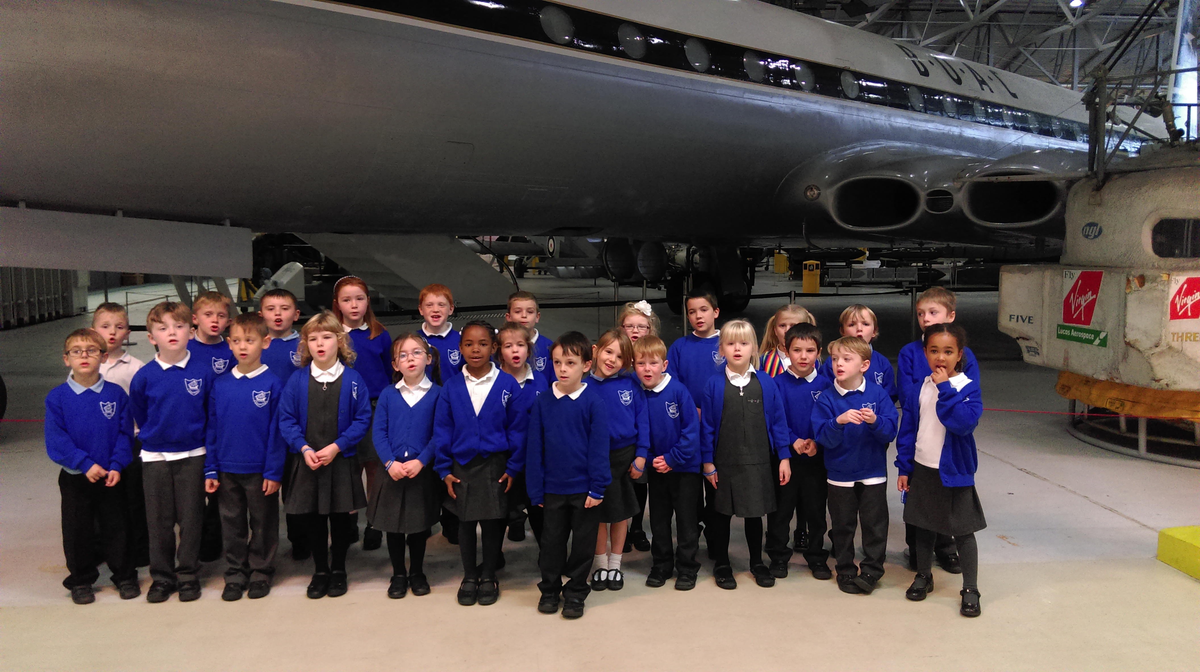
We have been looking at the colourful season of autumn that is upon us. We have looked at the changes of the trees and the weather, discussing how the days are getting shorter. We also looked at the celebration of Harvest and thought about what we are giving thanks for. If you were at the Harvest Festival you will have heard some of the acrostic poems which we wrote about harvest.
As we return from our half term holidays, I am looking forward to our topic taking us into space, I wonder what we will find?

Mrs Heidi Smith
NEWS FROM SQUIRRELS

Since our last update Squirrels have been busy outside. We now have a mud kitchen and outdoor café which has been very popular in the sunny weather. Treats on offer include hot chocolate sprinkled with nuts!

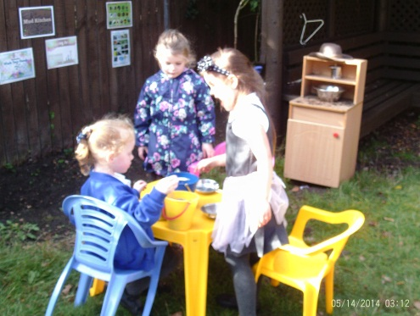

We also met up with our buddies from class 3 and invited them to our class to share a story or play a game. It is nice to know that there is someone older looking out for us especially at playtime.
We have also gained another Squirrel and would like to welcome Johnny to our school.
Mrs Julia Staley

NEWS FROM THE FRIENDS
The Friends tried something a little different for the Halloween disco on 23rd October. We invited all children who attend Willington Lower School to come to an evening of dancing, games and fun without their parents. This was a huge success, not only did everyone enjoy themselves but the children behaved brilliantly making it a good evening for the grown ups running it too. The disco raised over £80.
There was also a 'Wear it Pink' Mufti day and coffee morning in aid of Breast Cancer on the same day. We raised and amazing £136.82 for the charity. A special thank you to Emma Parker who hosted the event at the last minute and everyone who provided cakes.
We have the Christmas Fair which is being held on Saturday 5th December at Willington village hall between 12.00pm and 2.00pm. Please contact any of the Friends if you can help on the day or could donate anything for the raffle.

BE A HERO FOR CHILDREN IN NEED!

Friday 13th November is Children in Need Day. The school council thought it would be great if everyone came in dressed as a hero or superhero. Please bring in a donation of £2 for this great cause.

Thank you!
The School Council
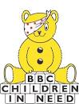

UPDATE ON THE REPLACEMENT BUILDING

As you will have noticed, the Care Club building has been removed during half term.
Care Club is operating in Oak class during November & December. The new building should be delivered on 28th November and lowered into place with a giant crane!
We will keep you informed as plans progress.
CONTACT DETAILS REMINDER

Our email address has changed to office@willingtonlowerschool.org

Our phone number remains as 01234 838280.

UNIFORM
Please ensure children come to school wearing the appropriate uniform. Fashion jewellery and nail varnish is not permitted. Earrings should be studs only. This is a good habit to get into and standard practice in most schools.
PARENTS QUESTIONNAIRE

Thank you very much for returning the parents’ questionnaire that was sent out before half term. Results are attached.
Whilst we are delighted that so many of you are happy with the provision at Willington Lower School, we will work on the points raised by some of you to make sure that the service gets even better. Please remember that we welcome your suggestions and comments, the Suggestion Box is always in the entrance hall and is checked regularly. Alternatively, Mrs Dun is always happy to discuss any issues and will always make time to talk to you.

MESSY CHURCH

Making chocolate coins and biscuits, painting and filling your own mini First Aid Kit, decorating a glass or making a lantern, these are just some of the crafts we have been doing at Messy Church, an after school activity that happens once a month on a Wednesday. The craft activities are followed by a story and a song, and then a simple meal is served for everyone, e.g. pasta, pizza, hot dogs or burgers.
Messy Church is held at the Methodist Church from 3.30 – 5.30. Lower School children and younger brothers and sisters are welcome and should be accompanied by an adult. The next two sessions will be November 25th and December 16th. There is no charge but please let us know if you can come so that we can get the catering right.
Tel. Keith and Pat 01234 838667,
Text 07597 330362 or email liliaceous48@gmail.com
The Kidzone Team

CONSULTATION

All parents should have received their copy of the Consultation, either by Parentmail or as a hard copy. Please contact the office if you have not received yours. Your views and suggestions are very important to us and you are invited to a meeting at 7pm on Tuesday 17th November at the school to ask any questions you may have.

DIARY DATES:
NOV  13th  18th  19th  25th  27th  30th  DEC  1st  8th  9th  10th  15th  18th  JAN 2016  4th  5th | Children In Need  Bedford Faith Tour for Years 1,2,3,&4  Individual and family group photos  Visiting Artist to lead a session with each class  Coffee Morning with Mrs Dun – an opportunity for parents/ carers to have a drink and a chat 9am-10am  Full Governing Body Meeting 7pm  Visiting Artist to lead a follow up session with each class  Dress Rehearsal of Christmas Play 10am  Riding School Christmas Party  Performances of Christmas Play  2pm and 6.15pm  Pantomime at Wellingborough Theatre  Church Service 9.30am  Last day of term  Staff training day  Children return to school

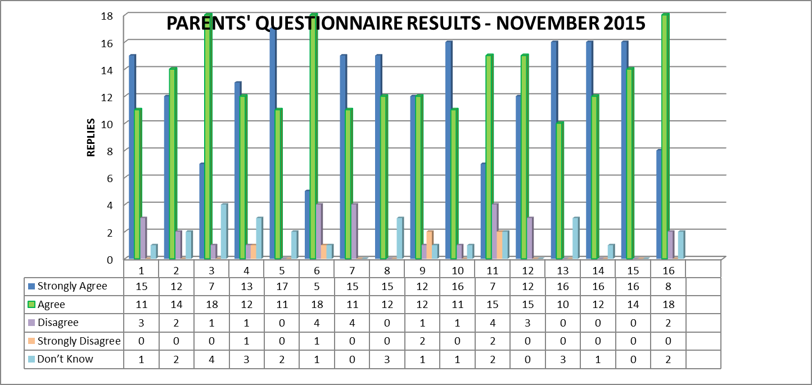
Questions:
- My child likes school
- My child is making good progress
- Children/pupils behave well
- My child is not bullied or harassed
- Teaching is good
- I’m kept well informed about how my child is getting on
- I feel comfortable about approaching the school with questions, problems or complaints
- Staff expect my child to work hard and do their best

- The school is well led and managed
- Staff treat my child fairly
- The school seeks the views of parents and takes account of their suggestions and concerns
- The school provides appropriate homework
- The staff encourage my child to become mature and independent
- There is a good range of activities that my child finds interesting and enjoyable
- The arrangements for my child to settle in when they started were good
- I feel that all children are offered excellent extra curricular activities

